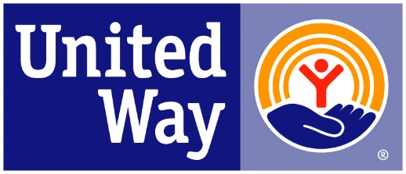
United Way of the Ohio Valley

IMPACT FUNDED PROGRAM EXPECTATIONS
2023-2024
- United Way of the Ohio Valley is investing in organizations who believe in a creative and collaborative network to create and sustain change that supports a safer and healthier community.

- This collaborative network will be composed of the United Way Organization and impact funded programs who are determined to meet the requirements of the United Way Model.

- United Way and funded programs will both uphold standards of best practice to ensure that the current needs of our community are addressed strategically and with the utmost commitment to create lasting change for the betterment of our citizens.

- The network partnership will recognize the collective impact as a system of care designed to make an impact in one or more of the focus Impact areas; Affordable Housing, Homelessness, and Financial Stability/Income.

- The funded program will submit any progress reports requested by United Way.

- The funded program will cooperate, if needed, in the Community Investment (CI) process by agreeing to interviews, agency tours, or financial reviews if requested by CI volunteers.

- United Way of the Ohio Valley will be available to funded programs to act in a supportive role with additional assistance provided whenever possible that may promote the growth and quality improvement of the program and its leadership.

- The funded program will ensure that the community is aware that the organization is supported and funded by the United Way of the Ohio Valley through various means such as social media, website, newsletter, and other marketing materials.

- Both the United Way and funded programs will strive to support the work of each organization through positive awareness, education, and promotion of collaborative opportunities.

Agency Name: _________________________________________________

______________________________ _________________________________
Agency Executive Director/CEO United Way of the Ohio Valley/ CEO

______________________________ _________________________________
Date Date

