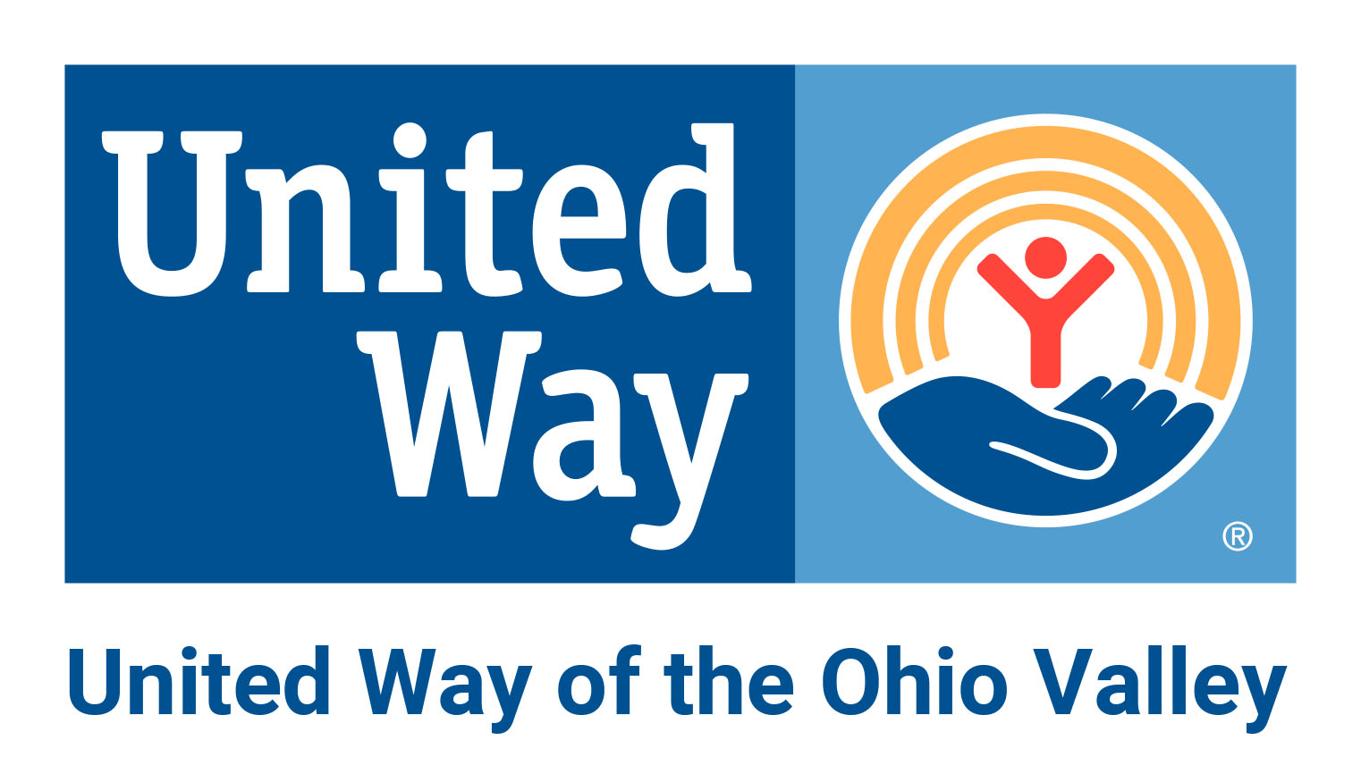

This form is to acknowledge that the Program Director and the Program’s Board Chair are in agreement on the 2023-2024 Impact application being submitted for request of UWOV funding and both agree to the services that will be provided if this program receives Impact funding as outlined in the application.
Both will also agree if leadership changes within the program-funded year, UWOV will be notified, and an updated form will be completed.

Program Director ________________________ Date: ________

Program Board Chair _____________________ Date: ________

