 ­

. . . . . . . . . . . . . . . . . . . . . . .

**How Your Dollars Help!**

With a donation each paycheck, you can make a difference for local children, families, and individuals from cradle to career.

Provides over 200 pounds of nutritious food for a struggling family

Provides a gas card for five cancer patients to ensure they can travel for specialized care



Provides free after school tutoring for a local student



Provides 15 nights of shelter and counseling for a victim of violence and their child



Provides a daily home delivered meal to an elderly person for 12 months.

$20 per week

$15 per week

$10 per week

$5 per week

What is United Way’s Perspective?

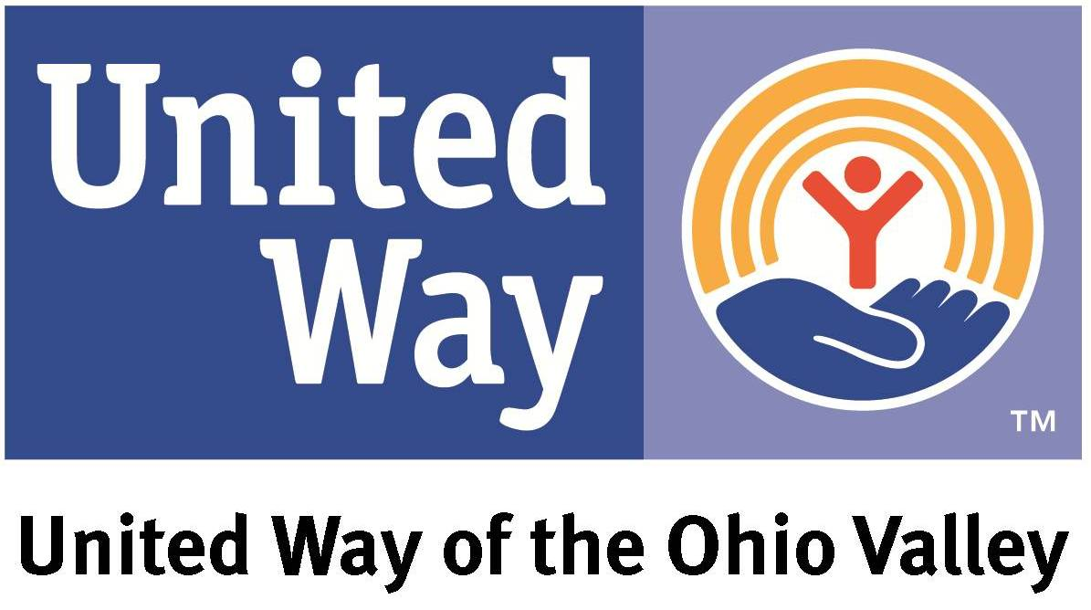

**WE EMPOWER VOLUNTEERS TO MAKE A DIFFERENCE.**

We engage volunteers to give back and strengthen the community.

**WE DO OUR RESEARCH.**

We invest in the areas of most need in our community with a focus in

Education, Health and Financial Stability.

**WE TACKLE ISSUES HEAD ON.**

We provide cradle to career support that helps local individuals achieve

their personal success

**WE FUND PROGRAMS THAT CREATE CHANGE.**

We help children enter school ready to learn, help high school

students reach graduation day, support people working to earn a

degree or certification, and help individuals find good jobs to support

themselves and their families.

  

5,055

Children benefited from educational programs from head start to high school

3,587

People from birth to end of life care received help from programs and services for support, companionship, and treatments

10,171

People benefited from services that supported self- sufficiency, human needs, and financial assistance

$30 per week

Join the Fight

Visit UWOV.org today

United Way of the Ohio Valley

270-684-0668| uwov.org