

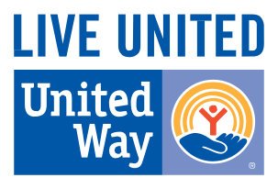

**UNITED WAY**

ADVANCES THE COMMON GOOD

We focus on protecting services for the most vulnerable members in our community, while making long term investments in EDUCATION, FINANCIAL STABILITY AND HEALTH, because these are the building blocks for the best quality of life.

We believe we all win when a person succeeds in school and life, when a neighborhood turns around, when families have good health and workers have solid jobs.

We bring people and organizations together from all across the community who have the PASSION, EXPERTISE AND RESOURCES needed to get things done. We invite you to get a NEW PERSPECTIVE and be part of the change.

**United Way**

**of the Ohio Valley**

UWOV.org

GreenRiver211.org

**CONNECTING THE COMMUNITY**

United Way strengthens our community and creates opportunity for every citizen by developing partnerships to address our greatest challenges. United Way works with local programs to provide resources to individuals and families in crisis today, while working year-round to improve community conditions and create lasting solutions. We are effectively building a strong foundation for our community’s future health and well-being.

# A COLLABORATIVE APPROACH

The needs of our community are interrelated and helping families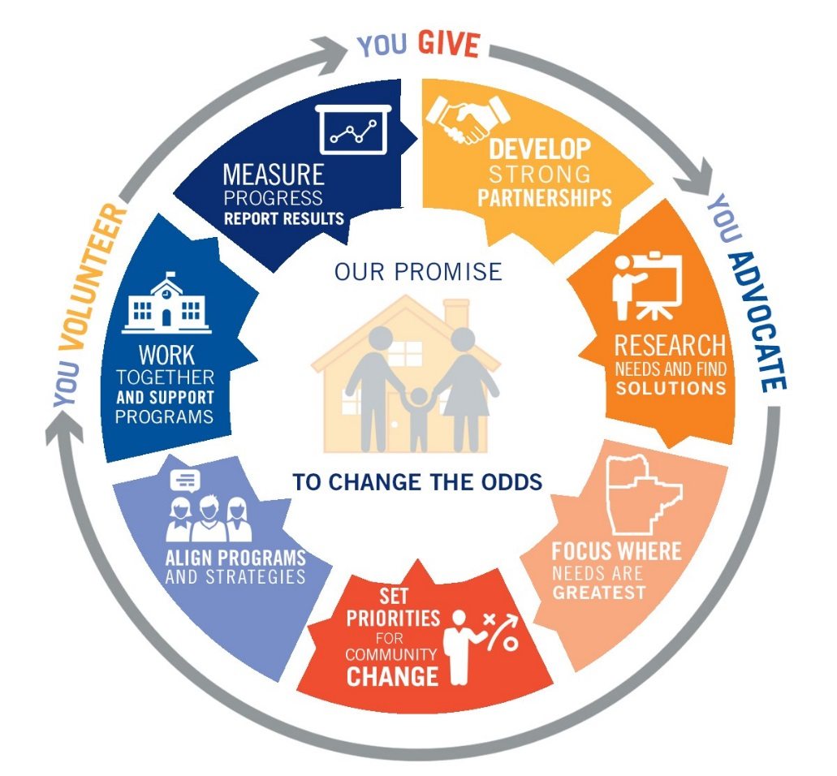 requires a comprehensive results-oriented approach. Initiatives like 2-1-1; Hunger Relief are where we convene people, groups, organizations to resolve community conditions.

# HOW DO YOU CONNECT PEOPLE WHO ARE STRUGGLING WITH THE RESOURCES THEY NEED?

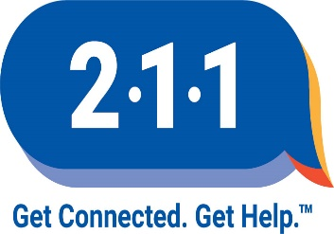Every year hundreds of families living in our community turn to 2-1-1 for information and support—whether financial, domestic, health or disaster-related. 2-1-1 is a free, confidential referral and information helpline that connects people from all communities and of all ages to the essential health\ and human services they need, 24 hours a day, seven days a week.

# THE BUILDING BLOCKS FOR A GOOD QUALITY OF LIFE.

Education, financial stability and health are the building blocks for a good life. Education is essential to getting and keeping a job with a livable wage and health benefits. An income adequate to pay for today’s necessities and save for the future provides families some sense of financial stability. Access to quality health care keeps children on track in school and adults productive at work. Remove any one of these building blocks and the other two topple.

### EDUCATION

#### Helping children and Youth Achieve Their Potential

* School Readiness for children from birth to 5 years of age
* Reading and comprehension skills for children entering 4th grade
* Middle School Students develop the needed skills to ensure success in high school
* Students graduate from high school on time prepared for college, career, and life

**FINANCIAL STABILITY**

Promoting Independence and Helping People in Times of Crisis

* Training and education that leads to careers
* Basic needs are met when families receive income support/subsidies
* Services to ensure affordable and safe housing
* Managing expenses and budgeting skills achieved

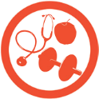

**HEALTH**

Improving People’s Health

403 Park Plaza Drive

Owensboro, KY 42301

**UWOV.org**

**GreenRiver211.org**

* Homes are free from violence and physical hazards
* Children start life with prenatal care and healthy birth
* Early development supported by primary and preventive care
* 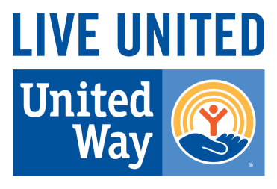Access to nutritious food and to pursue regular physical activity

